**Traffic Management**

**System**

**Circuit diagram:**

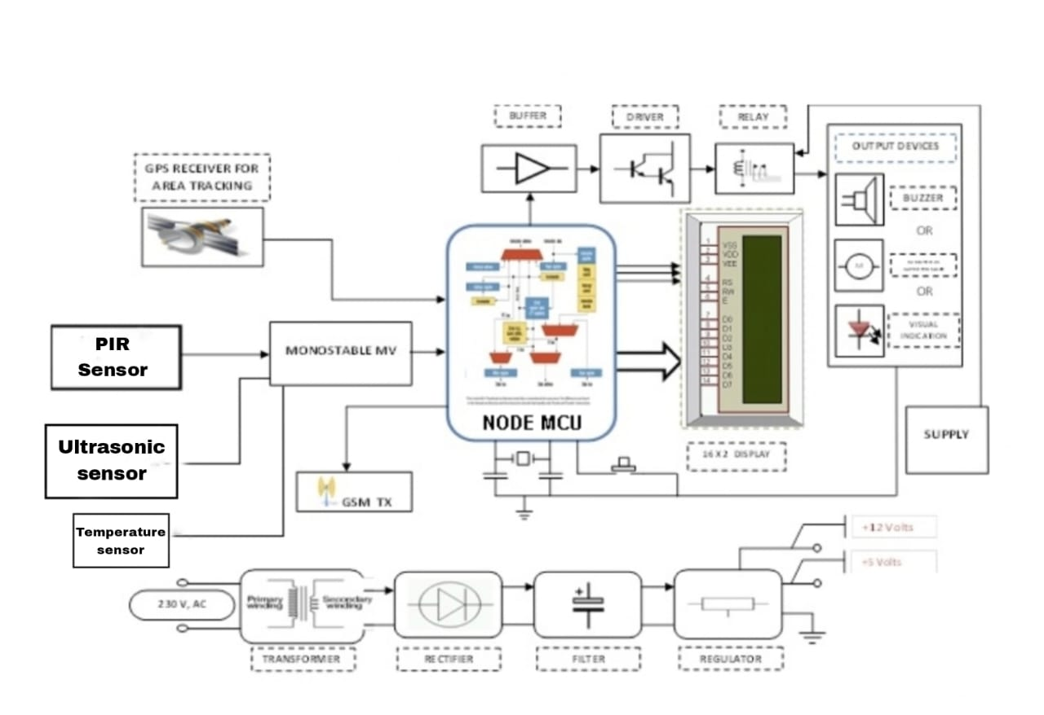

**PIR Sensor:**

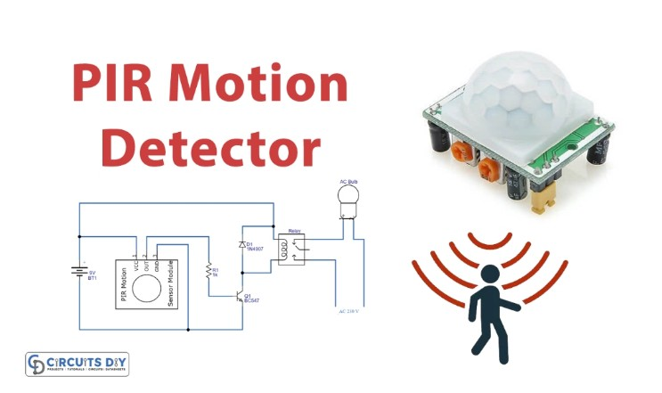

**Working and explanation:**

**In this PIR Motion Detector Circuit, we are using the PIR sensor having three terminals, Vcc, Gnd, and output. The sensor requires very few components to connect with. The sensor provides the output when detects any motion. When it detects any motion, it gives the signal to the transistor connected in a circuit, working as a switch. The collector terminal is connected with the relay. The other end of the Relay is connected to the positive supply. The electric bulb is connected with a normally open terminal of the relay. So, the Relay turns on then the common pin makes a connection with the normally open pin and then the bulb starts to glow**

**In automation circuits.**

**Application and uses:**

**In security circuits**

**Moreover, for security purpose**

**Further, in the home automation systems**

**Alson intruder alarm circuits.**

**Intand-alone alarm circuits, etc.**

**Flow chart:**

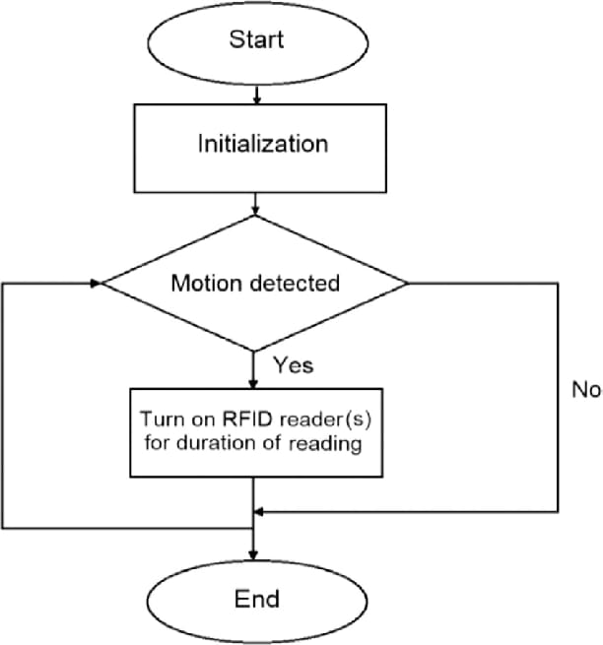

**Algorithm:**

**Step-1: Start the program.**

**Step-2: Initialisation the program.**

**Step-3: If motion is detected then**

**goes to next step, if it’s not**

**detected it ends up the**

**program.**

**Step-4: Turn (ON) RFID reader for**

**duration of reading.**

**Step-5: End of the program.**

**Block diagram:**

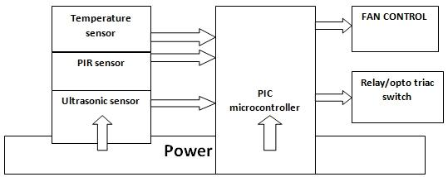

**Temperature sensor:**

**A temperature sensor is a device used to measure temperature. This can be air temperature, liquid temperature or the temperature of solid matter. There are different types of temperature sensors available and they each use different technologies and principles to take the temperature measurement.**

**PIR Sensor:**

**Passive Infrared Radiation (PIR) sensor detects the change in infrared radiation of warm blooded moving object in its detection range. According to the change in infrared radiation, there will be a change in the voltages generated which was amplified and used to turn ON the webcam and lighting system through relay.**

**ULTRASONIC Sensor:**

**An ultrasonic sensor is an instrument that measures the distance to an object using ultrasonic sound waves. An ultrasonic sensor uses a transducer to send and receive ultrasonic pulses that relay back information about an object’s proximity.**

**PIC Microcontroller:**

**PIC Microcontroller is the very smallest microcontroller in the world that can be designed to carry out a huge range of tasks. These microcontrollers are in electronic devices such as phones, computer, and Embedded Operating System etc.**

**FAN CONTROL:**

**Fan control is the management of the rotational speed of an electric fan. In computers, various types of computer fans are used to provide adequate cooling, and different fan control mechanisms balance their cooling capacities and noise they generate**